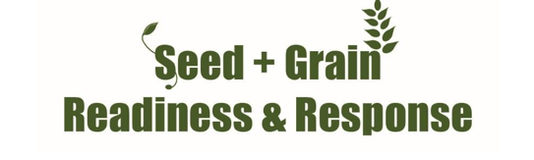

FALL ARMYWORM UPDATE
3rd February 2023
Key Points:
- A fall armyworm larvae has been confirmed on fodder beet paddock in Central Otago this week. This shows the pest could be found on leaves of different crops and can be found in southern regions as temperatures warm.
- Since 1st September 2022 there have been 100 confirmed FAW finds (this is the number of properties where the pest has been found, not the number of insects found)
- Adult fall armyworm (moths) are now being detected in high numbers in Northland, marking the final (adult) stage of the second generation indicating a third generation of larvae is imminent.
- ALL South Island maize and sweet corn crops should be scouted as well as ongoing surveillance in North Island.
- The insecticide Sparta has been approved for use on maize and sweetcorn crops.
- We are still in a response. All finds must be reported to https://report.mpi.govt.nz/pest or 0800 80 99 66
- There are no negative consequences to growers for reporting, as this pest will not be controlled by removing crops.
National FAW official data: as of Friday 3^{trd} February, MPI has confirmed FAW on 100 properties since 1 September 2022 (up 17 from last week). 12 of these finds have been in the West Coast of the South Island, and now one in Central Otago.
There have been no detections in Canterbury or any other regions in the east of the South Island but we are encouraging a high level of vigilance for Canterbury maize and sweetcorn crops, as the models suggest that conditions are now suitable for potential FAW development.
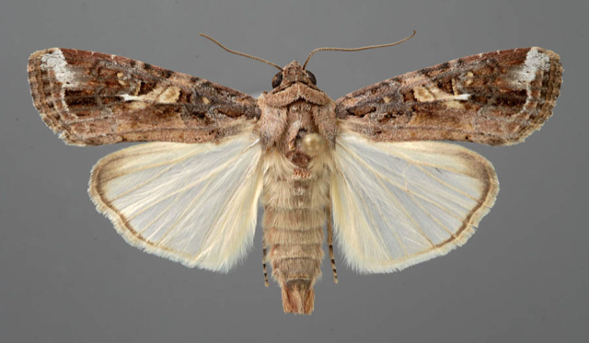
Photo: Fall armyworm moth.
The number of FAW moths caught in the response traps in the North Island has increased significantly in the past week marking the move from second to third generation.
The Insecticide Sparta (spinetoram 120g/L) is now on label for use on Fall Armyworm in maize and sweetcorn crops.
Please contact your local advisor for details on the safe use of this or any other insecticides on maize or sweetcorn.
Thresholds of economic damage
Plant Health Australia provides useful guidance for this:
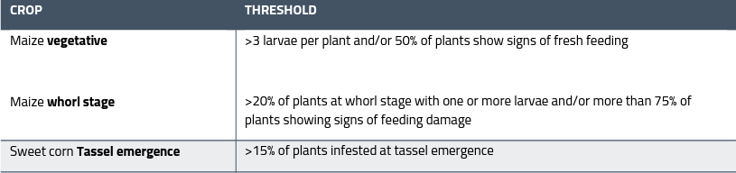
For useful tools and guides on detection and identification consult FAR website for the latest identification guides https://www.far.org.nz/assets/files/blog/files//8a209e4b-4ca8-5338-af06-f3b80bab18e2.pdf and MPI Website www.mpi.govt.nz/dmsdocument/50839-Fall-armyworm-fact-sheet or contact Ivan Lawrie ivan.lawrie@far.org.nz

